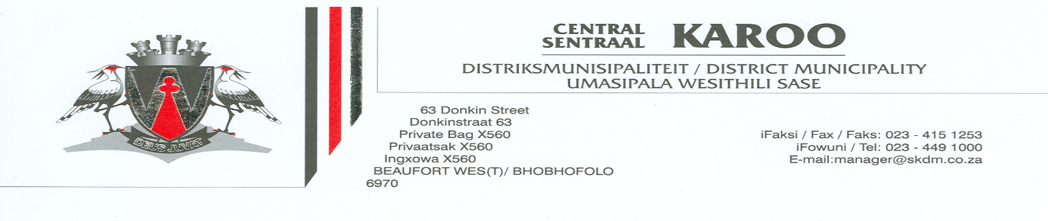

TENDER FOR SECURITY SERVICES

CKDM 18 – 2014/15

Detailed information regarding the tender documents are available during office hours. The physical address for collection of Tender documents is: 63 Donkinstreet, Beaufort West, 6970. (opposite ABSA Bank)

Documents will be available from Friday, 26 June 2015. A non-refundable deposit of R 50,00 is payable on collection.

The 80/20 preference points acquisition formula set out in the Regulations of PPPFA 2011 will be used to evaluate the tender. Points will be awarded to bidders for the procurement of their BBBEE status. Tenderers must submit an original and valid tax clearance certificate, issued by the South African Revenue Service, with the tender document. Also the companies municipal account and that of its Directors, not older than three months.

Canvassing of bid evaluations committee members or any officer in the service of the municipality is an ethical violation and may result in a tender is automatically disqualified.

Tenders must be valid for 90 days.

Queries relating to these specifications may be addressed to: Mr Kobus Theron at Tel: (023) 4491000,
Fax: (023) 4151253 or manager@skdm.co.za. Documents is available from Ms L Strümpher .

Only tenders which comply with the Council’s tender conditions and Supply Chain Management Policy will be accepted. VAT must be included in the tender price.

Tender in sealed envelopes, clearly marked “CKDM 18 – 2014/15 SECURITY SERVICE” must reach the undersigned by not later than 12H00 on Friday, 10 July 2015, when it will be opened in public at the offices of the Central Karoo District Municipality at the above mentioned address.

Council reserves the right not to accept any tender or part of it.

Telegraphic, telephonic, telex, facsimile, e-mail and late Tenders will not be accepted. Tenders may only be submitted on the Tender documentation that is issued.

S JOOSTE
Municipal Manager

